Styles of Art
In a gallery
- A group of students from an international school are visiting an art gallery. Here is the handout their Art teacher gave them to fill in during their visit. Match each style of art with its definition.
- Cubism  - Realism  - Impressionism  - Pop Art  - Surrealism | - A style of art including many bright, colourful brush strokes. The paintings do not have a lot of detail and they are usually outdoor scenes like landscapes.  - A style of art that shows items painted in a colourful way. It is inspired by comic strips, advertising, popular entertainment and everyday objects.  - A style of art where the subjects remind us of basic geometric shapes.  - A style of art that shows things exactly as they appear in life.  - A style of art where the paintings are generally based on dreams. They are filled with familiar objects painted to look strange or mysterious. | 1.  2.  3.  4.  5.

Artists and their styles
- Read the biographies of the artists below and complete the missing words.
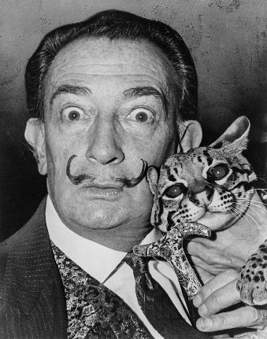
Salvador Dali was born in Spain in 1904. When he (1) ……… a child, he exhibited strange behaviour and often interrupted his class in school. As he got older, he started to paint pictures (2) ……… came from his dreams. His dreams and his paintings were scary and unreal. Dali (3) ……… to art school in Madrid, but he was expelled and never graduated. He even spent time in jail. However, he continued to paint, and his art style became known (4) ……… Surrealism. Salvador Dali drew everyday items, but changed them in odd ways. For example, one of his paintings is of melting clocks. Before he died at the age of 85 in 1989, Dali (5) ……… created works in film, ballet, opera, fashion, jewellery, and advertising illustrations.

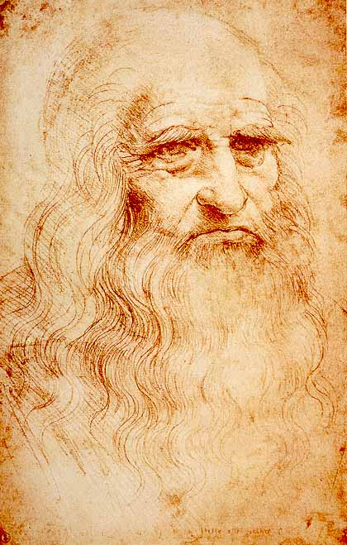
Leonardo Da Vinci was born in (6) ……… Italian town called Vinci in 1452. He lived in a time period called the Renaissance, (7) ……… everyone was interested in art. Even though Da Vinci was a great artist, he became famous because of all the other things he (8) ……… do. He was a sculptor, a scientist, an inventor, an architect, a musician, and a mathematician. When he was twenty, he helped his teacher finish a painting (9) ……… ‘The Baptism of Christ’. When he was thirty, he moved to Milan. That is where he painted most (10) ……… his pictures. Da Vinci’s paintings were done in the Realist style.

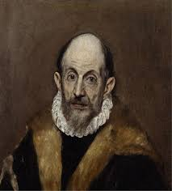
El Greco (1541–1614) was a painter, sculptor, and architect of the Spanish Renaissance. He usually signed his paintings in Greek letters (11) ……… his full name, Doménicos Theotokopoulos. He was born in Crete, (12) ……… was at that time part of the Republic of Venice and the centre of Post-Byzantine art. (13) ……… the age of 26, he travelled to Venice, as (14) ……… Greek artists had done. In 1570, he moved to Rome, (15) ……… he opened a workshop and created a series of works. In 1577, he moved to Toledo, Spain, where he lived and worked (16) ……… his death. El Greco led the way to the development of Expressionism and Cubism. His personality and works were a source of inspiration (17) ……… poets and writers such as Rainer Maria Rilke and Nikos Kazantzakis.

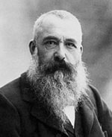
Claude Monet (1840-1926) was the primary inspiration for the new art movement of impressionism. He (18) ......... born in Paris. Even from an early age, he was fascinated (19) ......... nature and the way the sunlight illuminated meadows and fields of wheat. At school he was easily bored, preferring to spend time (20) ......... nature, or drawing ‘disrespectful’ caricatures of his teachers. As he was growing up, he developed a good reputation (21) ......... a charcoal impressionist. These caricatures (22) ......... him his first income from art and encouraged him to pursue art more seriously.
The first ‘impressionist’ exhibition was held in April 1874; it was a contemporary critic (23) ……… gave the gallery the term ‘impressionist’. This impressionist exhibition was a key moment in the development of modern (24) ………. He became a prolific painter, often working on a series of paintings – Monet was interested in how the same subject (25) ……… become a different impression as the sunlight changed. He would sometimes work on two or three canvas at the same time.

- Read the biographies again and decide if the following statements are True (T) or False (F).
- Dali was known for his antisocial behaviour. T/F
- Dali drew ordinary items exactly as he saw them. T/F
- Da Vinci was named after his birthplace. T/F
- Da Vinci had many different skills. T/F
- El Greco opened his workshop in Venice. T/F
- El Greco was born and died in Crete. T/F
- Monet didn’t earn any money from his caricatures. T/F
- The term impressionist was given by Monet. T/F

